Lab Report: Router Protection Using Password via Command Line Interface (CLI)
Objective
The objective of this lab is to configure two PCs connected to a Cisco router using Cisco Packet Tracer. The router will be assigned IP addresses to its interfaces, and password protection will be added to secure console and remote access through the Command Line Interface (CLI).
Software Used
- Cisco Packet Tracer
Devices and Components
- 1 Cisco 1841 Router
- 2 Personal Computers (PCs)
- 2 Copper Cross-Over (Ethernet) Cables
Network Topology Overview
PC0 Router PC1
Step-by-Step Procedure:
Step 1: Adding the Router
In Cisco Packet Tracer’s main workspace, a Cisco 1841 router was placed. This device will serve as the central network device that connects and routes data between the two PCs.
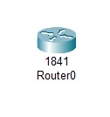
Figure 4.1: Adding the Router

Step 2: Adding Two PCs
Two end devices (PC0 and PC1) were added to the workspace. These computers will later be assigned unique IP addresses and connected through the router.
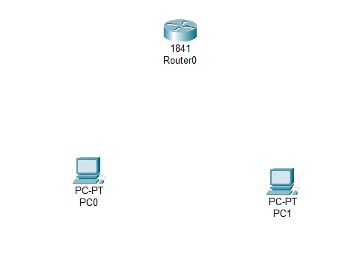
Figure 4.2: Adding Two PCs

Step 3: Connecting Devices
Each PC was connected to the router using copper Cross-Over cables.
- PC0 was connected to the FastEthernet0/0 interface of the router.
- PC1 was connected to the FastEthernet0/1 interface of the router.
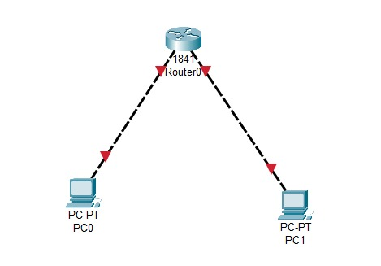
Figure 4.3: Connecting Devices
Step 4: Accessing the Router CLI
After the physical connections were made, we opened the CLI (Command Line Interface) tab of the router by double clicking the router icon then by going to the CLI option from navbar in order to configure the Router. When the router CLI was started, the system displayed the initial configuration dialog, which allows the user to perform setup tasks interactively. The setup process was started by selecting “Yes”.
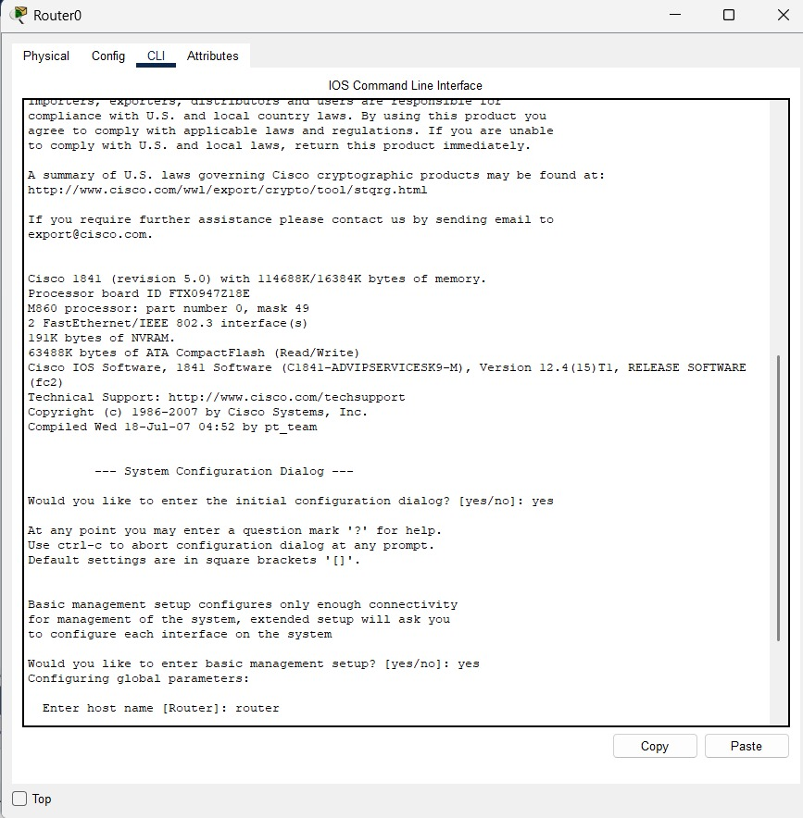
Figure 4.4: Accessing the Router CLI

Step 5: Entering Configuration Mode
From the CLI, configuration mode was entered after enabling the Router to allow modifications to the router’s settings. This mode gives administrative privileges to assign IP addresses and configure passwords.
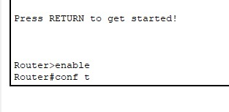
Figure 4.5: Entering Configuration Mode

Step 6: Configuring IP Addresses for Both PCs
Two of the router’s Ethernet interfaces were configured:
- The FastEthernet0/0 interface was given IP address and subnet mask for PC0’s network.
- The FastEthernet0/1 interface was given an IP address and subnet mask for PC1’s network.
After assigning the IP addresses, both interfaces were enabled to bring them online.
Messages appeared confirming that both interfaces had changed state to “up”, indicating successful activation.
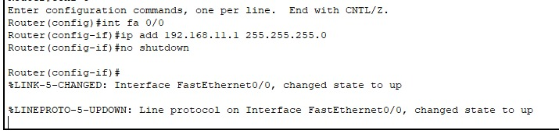
Figure 4.6.1: Configuring IP Address for PC0

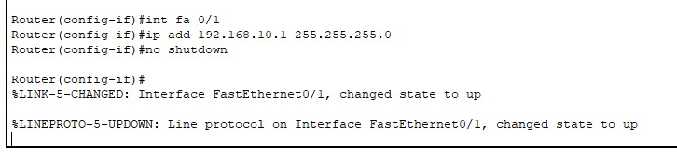
Figure 4.6.2: Configuring IP Address for PC1

Step 7: Setting Console Password
A console password was set to protect physical access to the router through the console connection. This means that any user who tries to access the router through the console will now need to enter a password before proceeding.
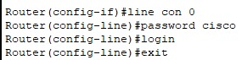
Figure 4.7: Setting Console Password

Step 8: Setting VTY (Remote Access) Password
A VTY password was configured to protect remote access to the router (for Telnet or SSH connections). For another layer of security by ensuring only authorized users can log in remotely.
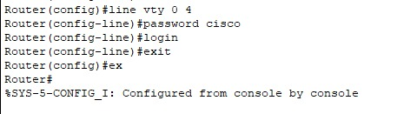
Figure 4.8: Setting VTY (Remote Access) Password
Step 9: Saving the Configuration
After completing all the necessary configurations, the router’s settings were saved by assigning a specific file name to the configuration. This step is essential because it preserves all the setup details such as IP addresses, routing tables, and interface settings within the saved file. By doing so, the configuration remains intact and can be easily restored even if the router or the entire simulation in Cisco Packet Tracer is restarted, or if the project file is closed and reopened later.
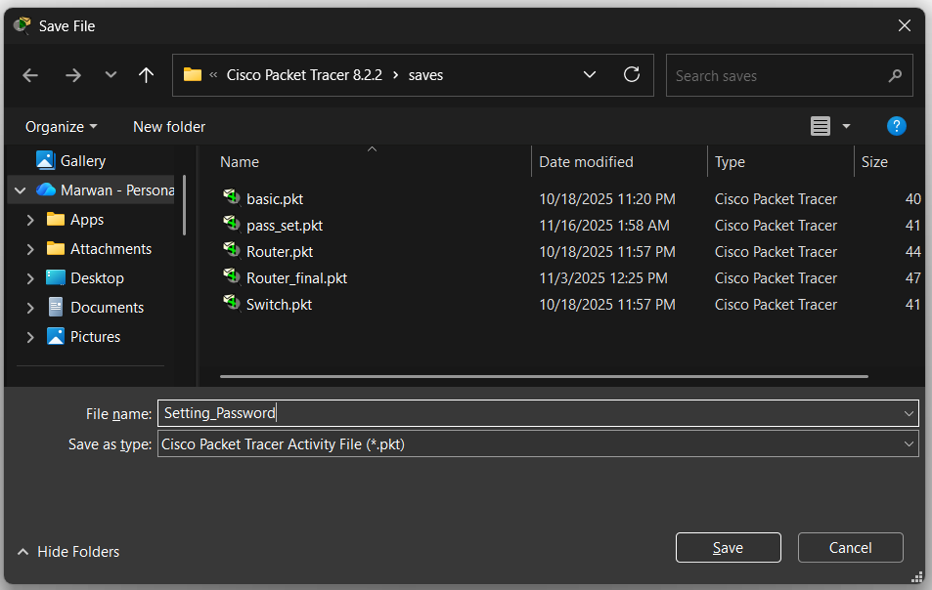
Figure 4.9: Saving the Configuration

Step 10: Testing the Password Protection
When the project file (.pkt) was saved and later reopened in Cisco Packet Tracer, the router’s Command Line Interface (CLI) prompted the user to enter a password before granting access. This prompt served as confirmation that the previously configured security measures were successfully applied. Both the console and VTY (Virtual Terminal) passwords were functioning as intended, demonstrating that the router was properly secured against unauthorized access. This step ensured that only authenticated users could interact with the router’s configuration, maintaining the integrity and safety of the network setup.
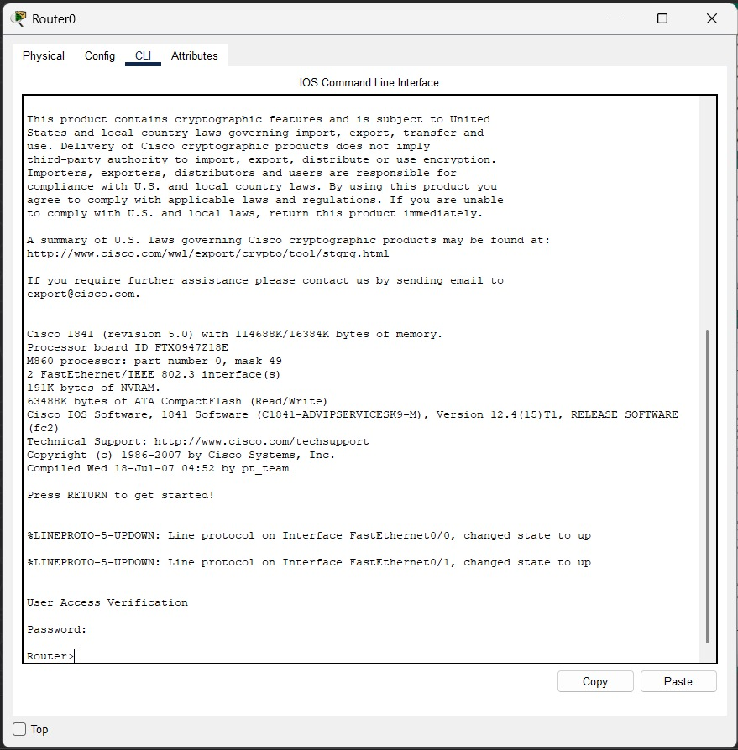
Figure 4.10: Testing the Password Protection

Results
- Both PCs were successfully connected to the router.
- Each router interface and PC was assigned a valid IP address.
- Console and VTY passwords were configured, and password protection was verified upon reopening the project.
- The router now requires authentication for both console and remote access, ensuring secure configuration management.
Conclusion
This lab demonstrated how to configure a simple network in Cisco Packet Tracer using a router and two PCs. It covered setting up physical connections, assigning IP addresses, enabling router Interfaces, and applying basic password security measures. The experiment showed the importance of securing network devices and validated the effectiveness of password protection in router management.

